**Laboratory Activity #1**

**Elmer S. Benitez II**

**BSIT 3-4**

Challenge 1:

Code:

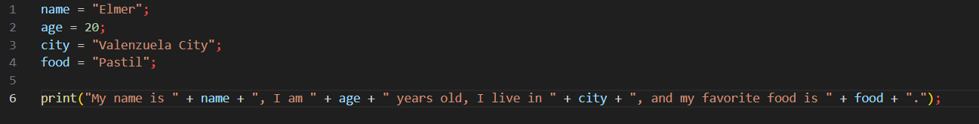

Output:



Challenge 2:

Code: